

**Module Code & Module Title**

**CS6P05NI Final Year Project**

**Assessment Weightage & Type**

**25% FYP Interim Report**

**Semester** **2023 Autumn**

**PROJECT TITLE:**

**VendorInsight: Advanced Vendor-Centric Analytics and AI-Driven Recommendations**

**Student Name: Nishant Parajuli**

**London Met ID: 22015718**

**College ID: np01cp4s220009**

**Internal Supervisor: Rubin Thapa**

**External Supervisor: Subash Basnet**

**Assignment Due Date: 3rd January 2024**

**Assignment Submission Date: 3rd January 2024**

**Word Count (Where required): 3698**

*I confirm that I understand my coursework needs to be submitted online via Google Classroom under the relevant module page before the deadline in order for my assignment to be accepted and marked. I am fully aware that late submissions will be treated as non-submission and a mark of zero will be awarded.*

**Abstract**

The interim report for the "VendorInsight" project presents the development of an advanced AI-driven e-commerce platform designed to enhance vendor and customer experiences in Nepal's growing digital marketplace. This report focuses on the project's progress, and future plans. It also focuses on the implementation of predictive analytics for sales optimization, personalized recommendation systems, and sentiment analysis, aimed at improving vendor decision-making and customer engagement. The report outlines the project's background, development process following Scrum methodology, analysis of progress compared to planned timelines, and outlines future work, including further development and testing phases.

Table of Contents

1. Introduction: 1

1.1. Problem Scenario 1

1.2. Project as a Solution 2

1.3. Aim and Objectives 3

1.4. System Architecture 4

1.5. Structure of the Report 5

1.5.1. Background 5

1.5.2. Development 5

1.5.3. Analysis or Progress 5

1.5.4. Future Work 5

2. Background 6

2.1. Project Elaboration 6

2.2. Review of similar systems 7

2.2.1. HamroBazar 7

2.2.2. Sastodeal 8

2.2.3. Daraz 9

2.3. Comparison Table 11

3. Development 12

3.1. Selected Methodology for Project 12

3.1.1. Scrum Methodology 12

3.2. Work Breakdown Structure (WBS) 15

3.3. SRS Document 16

3.4. Erd Diagram 16

3.5. High-level Use Case and Use Case Diagram 17

3.6. Collaboration Diagram 18

3.7. Class Diagram 19

3.8. Wireframe 19

4. Analysis of Progress 20

4.1. Progress Review 20

4.1.1. Expectations 22

4.1.2. Current Progress 22

4.2. Reason for being behind the timeline 23

4.3. Action Plan 23

5. Future work 25

5.1. Phases to Complete 25

5.1.1. Sprint 3 (Backend Development) 25

5.1.2. Sprint 4 (Vendor Analytics and Sales prediction tools) 25

5.1.3. Sprint 5 (Recommendation system and sentiment analysis) 25

5.1.4. Sprint 6 (Frontend development) 26

5.1.5. Sprint 7 (Testing) 26

5.1.6. Sprint 8 (Finalization) 26

References 27

6. Appendix 28

6.1. SRS Document 28

6.1.1. Introduction 28

6.1.1.1. Purpose 28

6.1.1.2. Project Scope 28

6.1.1.3. References 28

6.1.2. Overall Description 29

6.1.2.1. Product Perspective 29

6.1.2.2. Product Functions 29

6.1.2.3. User Classes and Characteristics 30

6.1.2.4. Operating Environment 30

6.1.3. External Interface Requirements 31

6.1.3.1. User Interface 31

6.1.3.2. Hardware Interfaces 31

6.1.3.3. Software Interfaces 31

6.1.4. System Features 32

6.1.4.1. Predictive Analytics for Vendor Sales (PAVS) 32

6.1.4.2. Personalized Recommendation System (PRS) 33

6.1.4.3. Sentiment Analysis of Customer Reviews (SACR) 33

6.1.4.4. Multi-Vendor Platform Management (MVPM) 34

6.1.5. Other Non-Functional Requirements 34

6.1.5.1. Performance Requirements 34

6.1.5.2. Safety Requirements 35

6.1.5.3. Software Quality Attributes 35

6.2. High level Use Case 36

6.2.1. User Registration and Authentication 36

6.2.2. Multi-Vendor Platform Management 36

6.2.3. Sentiment Analysis of Customer Reviews 36

6.2.4. Personalized Recommendation System 36

6.2.5. Predictive Analytics for Vendor Sales 36

6.2.6. Sales Analytics Dashboard 37

6.2.7. User Profile 37

6.2.8. Inventory Management 37

6.3. Wireframe 38

**Table of Figures**

Figure 1:The financial Inclusion factors in Nepal (DATAREPORTAL, 2023) 2

Figure 2: System Architecture 4

Figure 3: HamroBazar Product listing page 7

Figure 4: Analytics page for listed product for HamroBazar 8

Figure 5: Sastodeal product listing page for vendors 9

Figure 6: Daraz Home page 10

Figure 7: Scrum Methodology (Covetus, 2019) 12

Figure 8: Work Breakdown Structure 15

Figure 9: Initial ERD 16

Figure 10: Use Case Diagram 17

Figure 11: Collaboration Diagram for VendorDashboard 18

Figure 12: Collaboration diagram for ProductPage 18

Figure 13: Class diagram 19

Figure 14: Initial Gantt Chart 21

Figure 15: Updated Gantt Chart 24

Figure 16: Login Page wireframe 38

Figure 17: Home Page Wireframe 39

Figure 18: Explore Products Wireframe 40

Figure 19: Product Page Wireframe 41

Figure 20: Vendor Dashboard Wireframe 42

Figure 21: Vendor Ordered Products Page Wireframe 43

Figure 22: Vendor Product Listing Page Wireframe 44

**Table of Tables**

Table 1: Comparison table 11

Table 2: Progress Review table 20

# Introduction:

This project is focused on the development of a sophisticated web application targeted at e-commerce platforms which leverages artificial intelligence to enhance the vendor and

customer experience. At the core of this application, it is designed to pioneer advanced analytics in sales optimization and to pioneer personalized recommendation systems for

e-commerce sales. The intent of the project is to construct a multi-vendor e-commerce platform enriched by AI-driven capabilities, most notably a recommendation engine using sentiment analysis of customer reviews and predictive analytics which will help to boost vendor sales optimization.

## Problem Scenario

As Nepal navigates its e-commerce evolution, statistical insights reveal a market ripe for innovation. With a predicted revenue of US$603.1 million in 2023 and a compound annual growth rate of 9.1%, the e-commerce sector in Nepal shows substantial potential for expansion (ecommerceDB, 2023)​​. There is a significant potential for the growth of ecommerce in Nepal as there are still significant portions of the population underserved by digital financial services as only around 18.8% of the population have made a digital payment in the past year (DATAREPORTAL, 2023). However, this growth presents challenges that this project aims to address:

1. Vendors are often without the necessary tools for deep analytics and precise sales forecasts, leading to suboptimal inventory and pricing decisions.
2. Current recommendation systems may not effectively harness customer feedback and sentiment to generate personalized suggestions, possibly leading to lower engagement and satisfaction levels among shoppers.
3. Traditional e-commerce platforms may not offer seamless integration and management solutions for multiple vendors, leading to operational inefficiencies and a lack of competitive variety for customers.

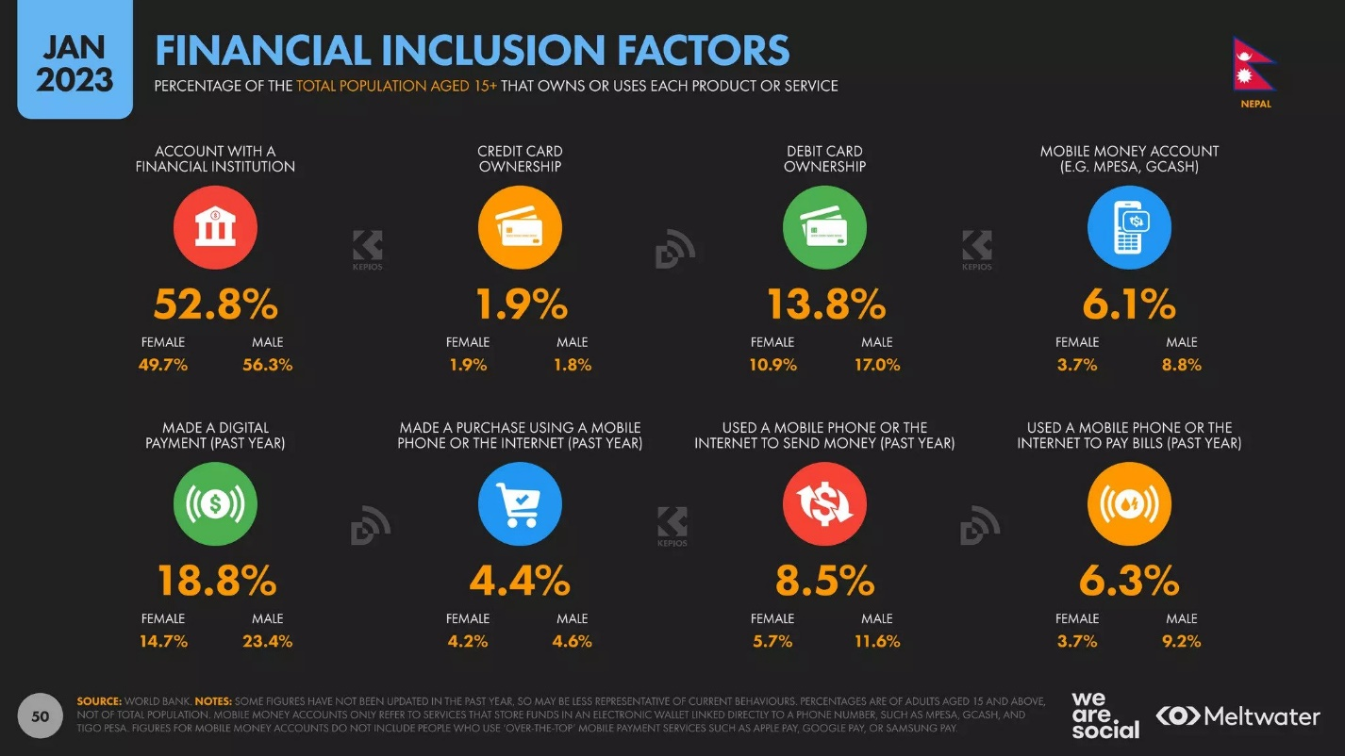

Figure :The financial Inclusion factors in Nepal (DATAREPORTAL, 2023)

## Project as a Solution

This project aims to develop an advanced e-commerce platform equipped with predictive analytics capabilities to assist vendors in optimizing their sales strategies while enhancing the shopping experience for customers in Nepal. The key features of this solution include:

1. Predictive Analytics for Vendor Sales:

* Sales Forecasting: Employing machine learning algorithms to analyse historical sales data along with market trends to provide accurate sales forecasts for vendors.
* Inventory Optimization: Utilizing predictive analytics to suggest optimal inventory levels, thus reducing carrying costs and the risk of stockouts.

1. Enhanced Recommendation Systems:

* Personalized Recommendations: Leveraging customer data, purchase history, and real-time behaviour to generate personalized product recommendations, enhancing customer satisfaction, and boosting sales.
* Sentiment Analysis: Analysing customer reviews and feedback to identify product trends and customer preferences, further refining the recommendation engine.

1. Multi-Vendor Platform Management:

* Vendor Dashboard: Providing an intuitive dashboard for vendors to manage their store, view analytics, and adjust pricing and inventory.
* Seamless Integration: Offering seamless integration solutions for multiple vendors to easily onboard and manage their products on the platform.

## Aim and Objectives

The primary aim of this project is to create a vendor focused analytics webapp for ecommerce platforms which includes features such as advanced recommendation which implements sentiment analysis as a feature for the recommendation model.

The Objectives of the project are:

1. Design and develop a predictive analytics tool for accurate sales forecasting, inventory optimization, and dynamic pricing.
2. Implement an enhanced recommendation system utilizing personalized recommendations and sentiment analysis to boost customer engagement.
3. Create a multi-vendor platform management system that allows seamless integration, management, and competitive variety for vendors.
4. Evaluate the effectiveness of the predictive analytics and recommendation systems through real-time testing and feedback collection.
5. Ensure scalability and security of the platform to handle increasing data volumes and ensure data privacy.
6. Research Django Framework and integration of various AI models in the backend framework
7. Gain extensive knowledge on analytics on a business scale for various businesses.

## System Architecture

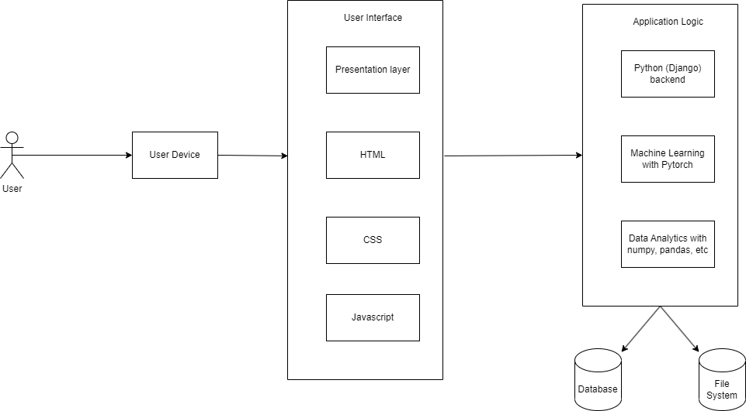

Figure : System Architecture

## Structure of the Report

## Background

This section will outline the foundational concepts behind the project addressing the needs it aims to fulfil in the e-commerce sector. It will include comparative analysis of existing e-commerce platforms, focusing on their limitations in vendor analytics and AI-driven recommendations. The background provides a better understanding of the project by clarifying the requirements and description of the project and its targeted customers.

## Development

This part of the report will cover all stages of the project’s development. The section will include key elements like methods used to start the development, stages of the project’s development segmented in a work break down structure to visualize it and Gantt chart illustrating the timeline of the project, reflecting the planned schedule versus actual progress.

## Analysis or Progress

This section of the report presents the research and development progress of the project.

In this part, a progress table is created which shows the tasks completed till date and tasks to be completed in the date expected. In this case, this section outlines the shortcomings faced on expectations of the initial Gantt chart and a solution is proposed to recover the time lost to accomplish the project within the time frame.

## Future Work

This is the final part of the report which will focus on the forthcoming phases of the project. It will detail the plans and strategies to accomplish the remaining project milestones within the predicted timeframe.

# Background

This application helps to solve the difficulties that vendors have to face which is the analytics of the products that they have listed on Ecommerce websites and also helps to solve the problem of recommending their products to interested users which will help in the boosting of revenue for the product. This application is developed as an Ecommerce Platform with heavy emphasis on the vendor usability, sales forecasting/analytics, and product recommendations.

## Project Elaboration

The project leverages combination of various Machine Learning/ Deep Learning algorithms to enhance the e-commerce experience. At its core Python Django is used for backend development and JavaScript, HTML5, CSS3, and Bootstrap for the frontend. The project’s standout feature is its AI features which includes AI-driven recommendation system which includes sentiment analysis of customer reviews as one of its features. It also includes features for vendor analytics and sales predictions. The AI features will be implemented using various powerful libraries in python such as Pandas, NumPy and Scikit-learn. The deep learning features for sentiment analysis will utilize Transformer Architecture at its core for analysing the sentiment of reviews using the library Pytorch. The sentiment analysis will be used both for analysis and recommendations. The recommendation system will utilize algorithms such as content-based filtering to display its recommendations to users.

## Review of similar systems

## HamroBazar

Hamrobazar is an online ecommerce platform which enables individuals as well as companies to list wide variety of new or used product online. This ecommerce platform utilizes itself to connect potential buyers and potential sellers (HamroBazar, 2023). Acquired by MNS Investments in March 2021, Hamrobazar has seen significant growth under the leadership of its new CEO, Rohit Tiwari, the founder of Foodmario (ShareSansar, 2021).

The estimated revenue of HamroBazar was found to be around 9$ and has an estimated 60 employees (owler, 2023). The platform is particularly known for its extensive range of products, including used vehicles, apparel, furniture, and electronic products. It serves as a comprehensive online classified marketplace, facilitating the sale and purchase of these items.

This overview of Hamrobazar demonstrates its prominence in Nepal's e-commerce landscape as a versatile and user-friendly platform for a wide range of products.

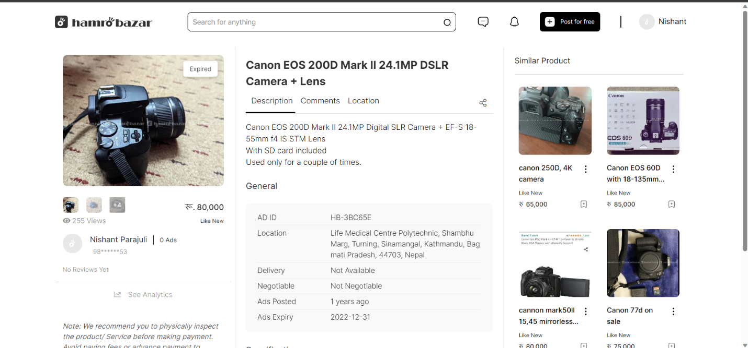

Figure : HamroBazar Product listing page

Figure : Analytics page for listed product for HamroBazar

## Sastodeal

Sastodeal, established on December 15, 2011, is one of Nepal's leading e-commerce companies. It has positioned itself as a major player in the online shopping domain, offering a wide range of products and services to millions of customers across Nepal. With its headquarters in Kathmandu, Sastodeal employs between 151 to 250 people and operates a logistics network that covers most parts of the nation, ensuring timely and affordable deliveries (yourstory, 2023).

Sastodeal's product range is extensive, catering to various customer needs. The categories include daily essentials such as food items, cooking ingredients, and beverages; electronics, featuring mobile phones, tablets, large home appliances, and televisions from leading brands; and a diverse selection of books, covering academic texts, various genres of literature, and professional development materials​​​ (Sastodeal, 2023).

With estimated revenue of the platform reaching around $3 million and 82 employees we can also see this is a successful form of business (rocketreach, 2023).

Figure : Sastodeal product listing page for vendors

## Daraz

Daraz is a prominent e-commerce marketplace in South Asia, operating in five countries, including Nepal. It has access to over 500 million customers and focuses on scaling its offerings across e-commerce, logistics, payment infrastructure, and financial services to provide a comprehensive end-to-end commerce solution in the region (Mikkelsen, 2022).

The company is focused on enhancing both the customer and seller experience, emphasizing retention and relevance to its users​​.

Daraz's strategy revolves around providing a core e-commerce solution, building a marketplace for both sellers and customers, and continuing to expand its customer and seller base. The company plans to continue investing in logistics, payment infrastructure, and offering financial services like payment through instalments (Mikkelsen, 2022).

Overall, Daraz's approach in Nepal is characterized by a focus on comprehensive market coverage, customer, and seller education, and expanding its services to meet the evolving needs of the e-commerce sector.

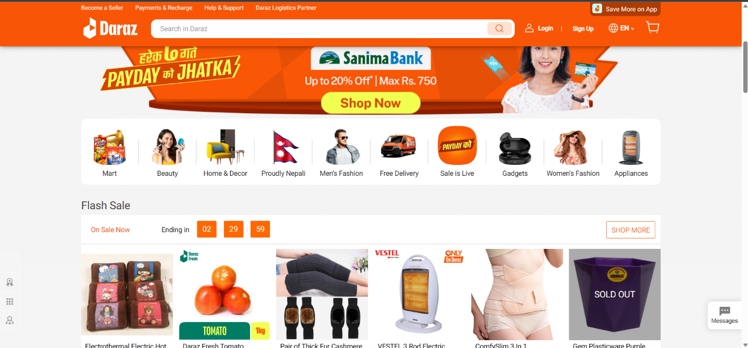

Figure : Daraz Home page

## Comparison Table

|  |  |  |  |  |  |
| --- | --- | --- | --- | --- | --- |
| SN | Feature | HamroBazar | SastoDeal | Daraz | VendorInsight |
| 1 | Multi-Vendor Platform Management | Yes | Yes | Yes | Yes |
| 2 | Customer Review | Yes | Yes | Yes | Yes |
| 3 | Vendor Product Sales Analytics | No | No | Yes | Yes |
| 4 | Personalized Recommendation System | No | Yes | Yes | Yes |
| 5 | Predictive Analytics of Vendor Sales | No | No | No | Yes |
| 6 | Inventory Management | No | No | No | Yes |
| 7 | Sentiment Analysis of Reviews | No | No | No | Yes |

Table : Comparison table

The Unique Features included in my project is the inclusion of Predictive Analytics of Vendor Sales, Inventory Management and Sentiment Analysis of Reviews. The predictive analytics of the vendor sales will help vendors more accurately gauge the reception of their products and help make proper business decisions regarding the products without the use of various third-party tools. Inventory Management also helps accomplish similar results as it too helps vendors make informed decisions regarding their products. The sentiment analysis of the products will help the users to find products that they may require or make purchases that they will require and will help to increase the user interaction in the site.

# Development

## Selected Methodology for Project

## Scrum Methodology

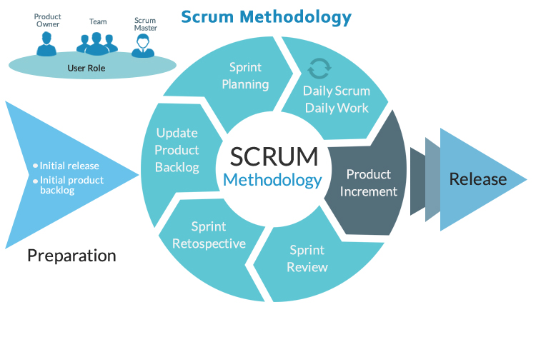

Figure : Scrum Methodology (Covetus, 2019)

The methodology that was chosen for the system is Scrum Methodology as it will allow me to rapidly make changes in areas that requires changes fast. The key focus of Scrum methodology is effective prioritization where it is easier to assign different priorities to different components of the project which will allow me to focus on the resources of the most important elements of the project.

The methodology has 5 stages which are:

1. **Initiation**

The initiation phase of a Scrum framework is the period in which you create a vision for your project. This includes important identification points, such as noting who the stakeholders are for the project and assigning the role of Scrum Master to yourself. During initiation, you determine the confines of your epic, which is the overall project your team is working toward.

1. **Planning and estimation**

During this phase, you create plans for a sprint, which is a short, time-boxed period that can help your team collaborate more effectively. As your team completes each sprint, you can then combine them later to complete all necessary elements in the project backlog. You can also use this time to create estimates about your expectations for the sprint, including what your team will deliver and when.

1. **Implementation**

The implementation phase is when you implement the sprint as planned. During this phase, you maintain an updated backlog, removing items as staff complete them and assigning out new items from the backlog as needed. You conduct daily standup meetings to provide project updates and review the work plans or concerns.

1. **Reviewing and Retrospect**

The reviewing phase focuses on assessing whether or not the Scrum team has met the Scrum goal. The Scrum Master leads the sprint review meeting and establishes what documentation should be produced. The team then looks at their work and decides if they have completed all of the tasks necessary to meet the sprint backlog.

1. **Releasing**

The last phase is the release phase, in which you deliver any final products to stakeholders, such as bringing a product to market or providing a client with the developed technology. After releasing the product, consider organizing a project retrospective meeting with your team to analyse the performance of each individual sprint and to discuss the overall performance of the project.

Scrum methodology was chosen as a suitable methodology for the project for the following advantages:

* Scrum is highly adaptable to changes, which is essential for individual projects where requirements may evolve over time. It allows for rapid adjustments and iterative development, which is ideal for responding to feedback or new insights.
* With its sprint-based structure, Scrum facilitates quicker releases of workable features or sections of the project. This means you can evaluate and refine the project continually, ensuring a better end product.
* Scrum's daily stand-ups and regular sprints provide clear visibility into the project's progress and any obstacles encountered. This offers better control over the timeline and deliverables, even for an individual.
* Since Scrum emphasizes prioritization and iterative development, it can be more cost-effective. It reduces the likelihood of extensive rework by catching issues early, and the iterative nature allows for adjusting the scope to align with available resources.

For this specific project Scrum methodology was chosen because of the highly adaptable nature of the methodology which is suitable for this project as it is a highly evolving project which can have a lot of adjustments over time. The Clear visibility of into the project progress provided by the regular stand-ups will help to make sure the project has its essential features covered and completed.

## Work Breakdown Structure (WBS)

Work breakdown structure helps in achieving the goals through a deliverable oriented work division. All the smaller tasks can be identified, scheduled, and budget can be allocated.

Figure : Work Breakdown Structure

## SRS Document

The full SRS document is provided in the appendix section of the report. SRS Document

## Erd Diagram

Figure : Initial ERD

## A diagram of a system Description automatically generatedHigh-level Use Case and Use Case Diagram

Figure : Use Case Diagram

The high-level Use Case is provided in the appendix section of the report. High level Use Case

## Collaboration Diagram

Figure : Collaboration Diagram for VendorDashboard

Figure : Collaboration diagram for ProductPage

## Class Diagram

Figure : Class diagram

## Wireframe

The wireframe is provided in the appendix section of the report.Wireframe

# Analysis of Progress

Analysis of progress sections includes the progress of final year project and how it is developing. This section helps to determine the actual progress of project by comparing with Gantt Chart. The process of project management was determined by the principles of scrum methodology as we progress through the project in sprints.

## Progress Review

|  |  |
| --- | --- |
| Milestone | Percentage Completed |
| Research about topic in depth | 100% (completed) |
| Requirements Gathering | 100% (completed) |
| User Experience Design | 100% (completed) |
| User Interface Design | 100% (completed) |
| Technical Architecture | 100% (completed) |
| Database Development | 70% |
| Backend Development | 20% |
| Data Preprocessing for analytics | 0% |
| Design and Training of Machine Learning Model | 0% |
| Implementation of analytics dashboard | 0% |
| Build Recommendation engine infrastructure | 0% |
| Build Sentiment analysis model | 0% |
| Integrate Sentiment analysis into recommendation system | 0% |
| Integrate Frontend System and Backend system | 0% |
| Testing | 0% |
| Product Finalization and deployment | 0% |

Table : Progress Review table

Figure : Initial Gantt Chart

## Expectations

The Expectations placed by the initial Gantt chart displays that each sprint is given a timeline of around a month each. The sprints include Research Gathering Sprint, Design Sprint, Backend Development Sprint, Analytics Dashboard Development Sprint, Sentiment analysis and Recommendation system Development Sprint, User Interface Development Sprint, Testing Sprint, and Finalization Sprint. According to the Gantt chart, we should have completed the Research Gathering, and Design Sprint by this point in time and near the completion of the Backend Development Sprint with only testing, fixing and deployment being left to be completed now.

## Current Progress

In the first sprint we selected the topic for the final year project, and we gathered information and researched about the selected topic for viability. The requirements for the project were also considered in this sprint. To gather the initial requirements, extensive research was done in the field of AI and many research papers were read during the requirement estimation. Research regarding various e-commerce platforms in Nepal and their vendor tools were also conducted during this sprint.

During the second sprint, we considered the user experience design and the user interface design with the help of a wireframe. The technical architecture of how the project would be constructed was also considered during this sprint. The design of the database was created to fit the requirements of our project during this phase. These designs are ever changing throughout the project but creating an initial design to follow helps to create a foundation for the project to be started on. We considered the algorithms to be used for the project during this sprint too.

The development of the backend system without the main AI features is ongoing with the development of the database being almost completed and the backend system being developed.

This is behind our schedule as we should have completed our backend system by now.

## Reason for being behind the timeline

The development of the project not progressing according to initial estimates are due to various factors during the development process. These factors include the addition of work from other coursework such as from AI module which was not managed properly for me to allocate enough time for the final year project. The design phase of the project required more time than what was initially planned because of difficult nature of the AI sections of the project to be designed in a proper fashion. The work needed to be done during the development phase was also slowed down due to mismanagement of my schedule and conflicting tasks from my internship work and college assignments.

## Action Plan

The project being behind schedule might have hampered our overall timeline, but we can recover from this minor setback because of the nature of our development methodology which allows us to adjust our schedule as per new needs in the project. The action plan to recover our lost time and get to schedule involves a modification to our Gantt chart which will allocate less time for less intensive sprints such as frontend development sprint and our finalization sprint as well as giving more time in our schedule for the project to complete our project within the time frame.

This may still have risks associated with it such as additional coursework being added during our sixth semester and having our examinations. We can also mismanage our time if we are not careful with our schedules. To remedy this we will strictly strive to work on our project daily without fail to account for any sudden complications to the development process such as difficulty on learning new concepts/ architecture for AI models, etc.

The updated Gantt Chart with our new plans and schedule is given bellow:

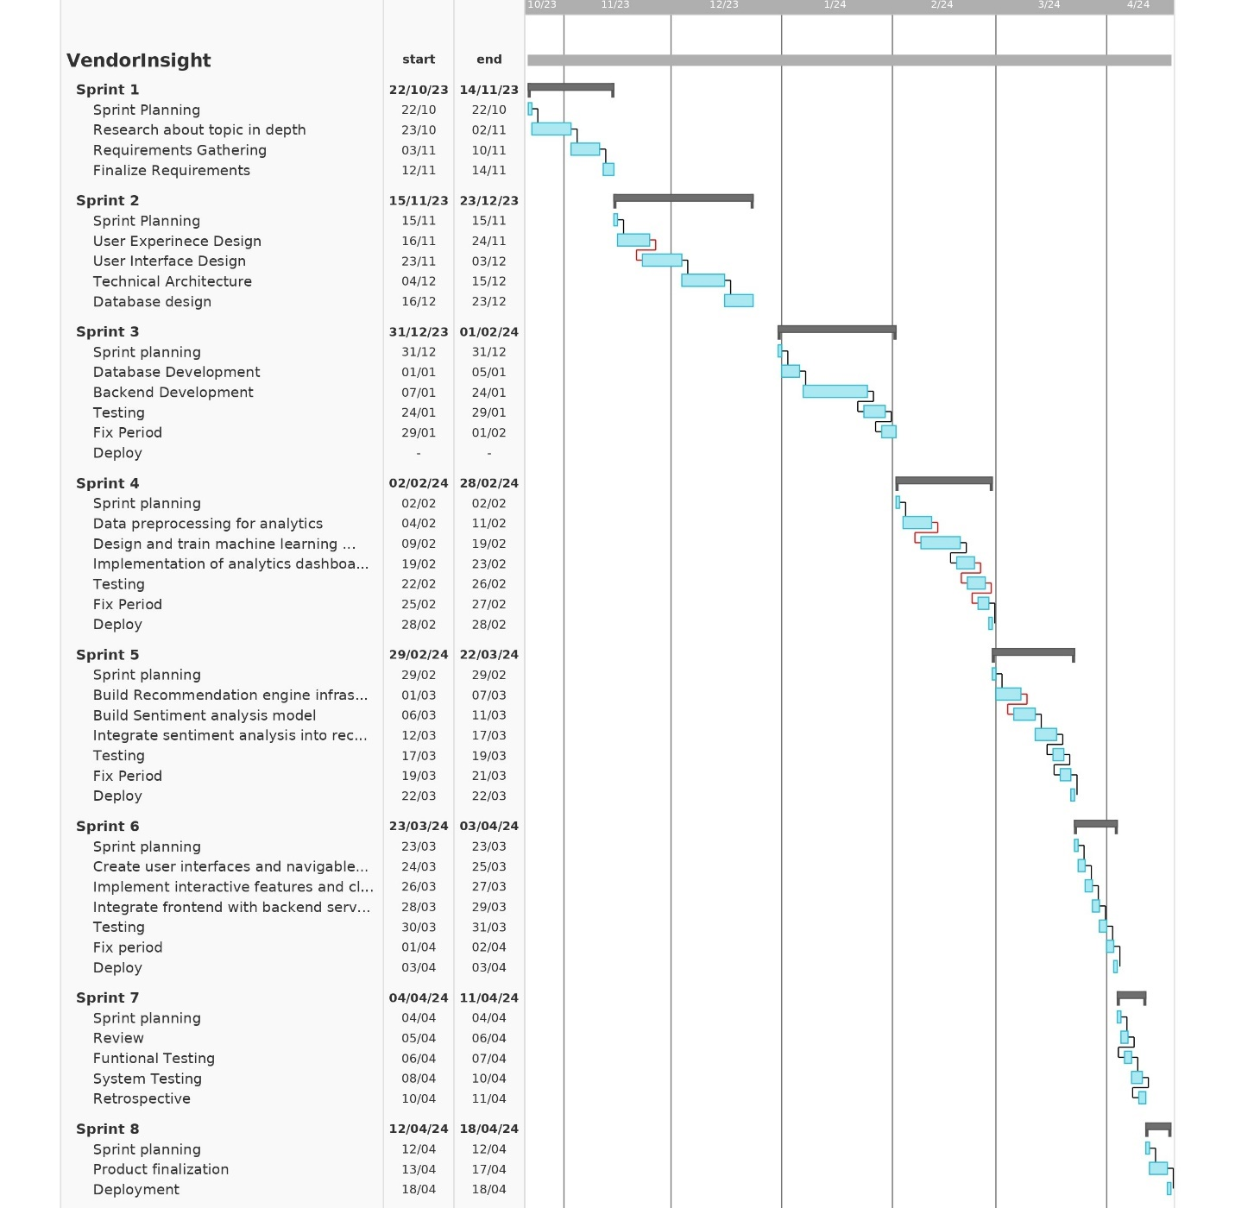

Figure : Updated Gantt Chart

# Future work

## Phases to Complete

## Sprint 3 (Backend Development)

In this sprint, we are presently working on the backend development. The backend will be based on the database that we have designed and developed. A rudimentary frontend using HTML, CSS and JavaScript will be created while working on the backend. The database POSTGRESQL will be used as the database engine powering the system. Our backend system will contain all the pages that are needed to be developed for the project. In this way, we will reach a significant milestone in our development process. This phase will take around 30 days according to the Gantt chart.

## Sprint 4 (Vendor Analytics and Sales prediction tools)

In this sprint, we will be working the analytics part of the vendor dashboard and also integrate the AI features that is required for vendors such as sales prediction and inventory management systems. This system will use algorithms which are built using sklearn library and pytorch. The vendors dashboard is also our main feature which will be completed during this phase. This phase will start from 26th January to 21st February according to the Gantt chart.

## Sprint 5 (Recommendation system and sentiment analysis)

In this sprint, we will be working on developing the recommendation system for the users which will be using algorithms such as content based filtering and collaborative filtering. The recommendation system will also use the sentiment of the reviews as a feature to recommend items to the user. The sentiment analysis will be conducted using product reviews as a source of data. The sentiment analysis part of the project will use Transformer Architecture which has been fine tuned for our need. This phase will start from 22nd February to 15th March according to the Gantt chart.

## Sprint 6 (Frontend development)

During this sprint we will be working on developing the frontend system of our project. The frontend will use proper user-friendly design for good visuals. The integration of various parts of our system will also be done during this stage. This phase will start from 17th March to 31st March according to the Gantt chart.

## Sprint 7 (Testing)

During this stage we will do various web applications test to see if our system is behaving properly or not. The testing will include Functional Testing, and System Testing. We will also do a retrospective during this phase to see if we have completed all our functional requirements or not. This phase will start from 1st April to 8th April according to the Gantt chart.

## Sprint 8 (Finalization)

The final stage of the project involves the final touch-up to be done for the project in case of any defect. Finally, we will deploy the product and complete our final documentation in this phase of the development.

# References

Covetus. (2019, April 18). *Agile Scrum Methodology for Project Management*. Retrieved from Covetus: https://www.covetus.com/blog/scrum-methodology-agility-with-endurance

DATAREPORTAL. (2023). *DIGITAL 2023: NEPAL.* Singapore: DATAREPORTAL.

ecommerceDB. (2023, October 1). *eCommerce market in Nepal.* Retrieved from ecommerceDB: https://ecommercedb.com/markets/np/all

HamroBazar. (2023, December 23). *FAQ*. Retrieved from HamroBazar: https://hamrobazaar.com/faq

Mikkelsen, B. (2022, April 18). ‘We are on a good track and Nepal is one of the fastest-growing markets’. (K. Prasain, Interviewer)

owler. (2023, December 23). *hamrobazar*. Retrieved from owler: https://www.owler.com/company/hamrobazaar

rocketreach. (2023, December 23). *Sastodeal Information*. Retrieved from rocketreach: https://rocketreach.co/sastodeal-profile_b5efed3ef42e7243

Sastodeal. (2023, December 20). *Sastodeal*. Retrieved from Sastodeal: https://www.sastodeal.com/

ShareSansar. (2021, March 10). *MNS Investments Acquires Popular Online Portal Hamrobazar*. Retrieved from ShareSansar: https://www.sharesansar.com/newsdetail/mns-investments-acquires-popular-online-portal-hamrobazar-2021-03-10

yourstory. (2023, December 23). *Sastodeal*. Retrieved from yourstory: https://yourstory.com/companies/sastodeal

# Appendix

## SRS Document

## Introduction

## Purpose

The purpose of this Software Requirements Specification (SRS) document is to provide a detailed overview of our product, VendorInsight. This web application is designed to revolutionize the e-commerce experience in Nepal by leveraging advanced analytics and AI-driven technologies to enhance both vendor performance and customer satisfaction. The SRS will outline the functionalities, system features, user interactions, and constraints of VendorInsight.

## Project Scope

VendorInsight is an ambitious project aimed at transforming the e-commerce sector in Nepal. This multi-vendor platform will not only provide a marketplace for vendors to sell their products but also offer advanced features such as predictive analytics for sales forecasting, inventory optimization, and AI-driven personalized recommendations for customers. This system will address the market's need for a sophisticated e-commerce solution that enhances user experience and optimizes vendor performance. The project scope includes the development of the web platform, integration of AI and machine learning algorithms for analytics and recommendations and ensuring a seamless user experience for both vendors and customers.

## References

IEEE. IEEE Std 830-1998 IEEE Recommended Practice for Software Requirements Specifications. IEEE Computer Society, 1998.

## Overall Description

## Product Perspective

VendorInsight is envisioned as a cutting-edge, multi-vendor e-commerce platform that integrates advanced artificial intelligence (AI) technologies to elevate both vendor and customer experiences. This platform distinguishes itself from traditional e-commerce systems by focusing on vendor-centric analytics and AI-driven recommendations. As a standalone product, it proposes a novel approach in the realm of digital commerce, specifically tailored to the burgeoning e-commerce market of Nepal. VendorInsight is not merely an addition to existing platforms but a comprehensive solution that addresses current market gaps with innovative features like predictive analytics for sales, sentiment analysis of customer reviews, and personalized recommendation systems.

## Product Functions

The primary functions of VendorInsight include:

* **Predictive Analytics for Vendor Sales:** Leveraging machine learning algorithms to offer sales forecasting and inventory optimization.
* **Personalized Recommendation System:** Utilizing AI to analyse customer behaviour and provide personalized product suggestions.
* **Sentiment Analysis:** Employing natural language processing to interpret customer feedback for improved product recommendations and vendor insights.
* **Real-Time Sales Analytics Dashboard:** Providing vendors with dynamic data visualization tools for performance tracking and decision-making.
* **Multi-Vendor Platform Management:** Featuring an intuitive dashboard for vendors to manage their inventory, view analytics, and adjust pricing.
* **Integration of AI Models:** Ensuring the backend, developed with the Django framework, seamlessly integrates various AI models for analytics and recommendation systems.

## User Classes and Characteristics

VendorInsight targets multiple user classes, including:

* **Vendors:** Businesses and individuals seeking advanced tools for sales optimization and market analytics.
* **Customers:** Users seeking a personalized shopping experience with recommendations tailored to their preferences and purchase history.
* **Administrators:** Platform managers responsible for overseeing platform operations and vendor coordination.

## Operating Environment

VendorInsight is designed to operate in a web-based environment, compatible with major browsers and adaptable to various devices (desktops, tablets, smartphones). The backend will be powered by Python and the Django framework, with the frontend utilizing technologies like JavaScript, HTML5, CSS3, and Bootstrap. The system will leverage PostgreSQL for database management and employ Git for version control.

# External Interface Requirements

## User Interface

* **Web Interface:** A web interface that ensures a consistent user experience. This includes clear navigation menus, intuitive dashboard layouts for vendors, and an easy-to-use interface for customers.
* **Vendor Dashboard:** An interactive dashboard for vendors to manage products, view sales analytics, and receive inventory alerts. This dashboard should be intuitive and provide comprehensive tools for managing e-commerce operations.
* **Customer Interface:** A customer-focused interface featuring personalized recommendations and easy access to product categories. It should also include a review and rating system for products.
* **Admin Panel:** A backend interface for system administrators to manage the platform, including user account management and content moderation.

## Hardware Interfaces

As a web-based application, VendorInsight does not directly interface specific hardware.

## Software Interfaces

VendorInsight will interact with several software components:

* **Web Browsers:** Compatibility with major web browsers like Chrome, Firefox, Safari, and Edge.
* **Database Systems:** Interface with PostgreSQL for structured data and MongoDB for unstructured or semi-structured data.
* **AI and ML Libraries:** Integration with AI and machine learning libraries (like PyTorch) for the recommendation engine and predictive analytics.

## System Features

## Predictive Analytics for Vendor Sales (PAVS)

* **Description and Priority:** High Priority. This feature enables vendors to access predictive insights about sales trends, inventory needs, and pricing strategies, using advanced machine learning algorithms.
* **Stimulus/Response Sequences:**
  + Stimulus: Vendors input historical sales data.
  + Response: The system analyses the data and provides sales forecasts and inventory recommendations.
* **Functional Requirements:**

REQ-PAVS-1: The system must analyse historical sales data to provide future sales trend forecasts specifically for the vendor.

REQ-PAVS-2: The system should offer inventory optimization suggestions based on predictive analytics, tailored to the vendor's needs.

REQ-PAVS-3: The system must allow vendors to input and customize data inputs and parameters for their specific analytics requirements.

## Personalized Recommendation System (PRS)

* **Description and Priority:** High Priority. This system leverages customer data to offer personalized product recommendations, enhancing the shopping experience and potentially increasing sales.
* **Stimulus/Response Sequences:**
  + Stimulus: Customers browse, search for products, or make purchases.
  + Response: The system dynamically updates and displays personalized product recommendations.
* **Functional Requirements:**

REQ-PRS-1: The system must implement AI algorithms to generate personalized product recommendations for each customer, based on their individual behaviour and purchase history.

REQ-PRS-2: The system should update recommendation lists in real-time, reflecting the current interactions of each individual customer.

## Sentiment Analysis of Customer Reviews (SACR)

* **Description and Priority:** High priority. This feature analyses customer reviews to understand sentiment, aiding in product recommendation and vendor insights.
* **Stimulus/Response Sequences:**
  + Stimulus: Customer submits a product review.
  + Response: The system processes the review for sentiment analysis and updates product insights.
* **Functional Requirements:**

REQ-SACR-1: The system must analyse text from customer reviews to determine sentiment, providing insights that are specific to each product (positive, neutral, negative).

REQ-SACR-2: The system should integrate sentiment analysis results into the recommendation engine and vendor dashboards, enhancing both customer experience and vendor insights.

REQ-SACR-3: The system must provide vendors with specific insights on customer sentiment for each of their products.

## Multi-Vendor Platform Management (MVPM)

* **Description and Priority:** Medium priority. This feature offers a comprehensive dashboard for vendors to manage their products, view analytics, and adjust pricing and inventory.
* **Stimulus/Response Sequences:**
  + Stimulus: Vendor logs into the dashboard to manage their store.
  + Response: The system presents a comprehensive view of sales, analytics, and management tools.
* **Functional Requirements:**

REQ-MVPM-1: The system should enable vendors to view and manage their product listings, including adding, updating, or removing products, specifically on their individual dashboards.

REQ-MVPM-2: The system must provide a real-time analytics dashboard to the vendor, showcasing sales data, customer demographics, and market trends.

REQ-MVPM-3: The system should allow vendors to adjust pricing and inventory based on analytics insights, tailored to their individual store metrics and performance.

## **Other Non-Functional Requirements**

## Performance Requirements

* **System Speed and Responsiveness:** The application should load within 3 seconds under normal conditions, with real-time updates in user dashboards.
* **Data Processing:** Predictive analytics and recommendation algorithms should process data and update results within acceptable time frames, not exceeding 5 seconds.
* **Scalability:** The system should be designed to sustain at least a 50% increase in concurrent user load and data volume per year, without any degradation in response time or processing efficiency.

## Safety Requirements

* **Data Integrity:** Implement checksums and transactional integrity checks to ensure that data remains accurate and uncorrupted during all stages of processing and storage.
* **Operational Safety:** The system must have redundancy mechanisms and failover protocols in place to prevent operational failures, aiming to reduce system downtime to less than 0.1% annually.

## Software Quality Attributes

* **Usability:** The user interface must ensure that navigation is intuitive, and the design is accessible, with an average user learning curve not exceeding 30 minutes.
* **Reliability:** The system should have a high level of uptime (aiming for 99.9%) and include with built-in error-handling capabilities to ensure continuous operation under normal conditions.
* **Maintainability:** Code should be well-documented and modular to ensure ease of updates and maintenance, with documentation coverage exceeding 95%.

## High level Use Case

## User Registration and Authentication

1. Actors: Customers, Vendors.
2. Description: Users register and create an account. Authentication is required for login and access to personal and vendor-specific features.

## Multi-Vendor Platform Management

1. Actors: Vendors, System.
2. Description: Vendors access a comprehensive dashboard for managing their products, viewing analytics, and adjusting pricing and inventory.

## Sentiment Analysis of Customer Reviews

1. Actors: Customer, Vendors
2. Description: The platform processes customer reviews for sentiment analysis, aiding in refining product recommendations and providing insights to vendors.

## Personalized Recommendation System

1. Actor: Customer
2. Description: The system generates personalized product suggestions for customers based on their browsing history and purchase patterns using AI algorithms.

## Predictive Analytics for Vendor Sales

1. Actor: Vendor
2. Description: Vendors use the platform to input historical sales data. The system then provides sales forecasts and inventory recommendations using advanced machine learning algorithms.

## Sales Analytics Dashboard

1. Actors: Vendors, System.
2. Description: A dashboard offering real-time sales data visualization, customizable reports, and metrics for vendors to make informed decisions.

## User Profile

1. Actors: Customer, Vendor
2. Description: Users (customers and vendors) create and maintain their profiles on the platform. This involves adding or editing personal and business information, setting preferences, and managing account settings for enhanced platform interaction.

## Inventory Management

1. Actors: Vendor, System
2. Description: Vendors manage their product inventory on the platform with assistance from the System. This includes viewing current stock levels, updating inventory based on predictive analytics, and receiving alerts for restocking.

## Wireframe

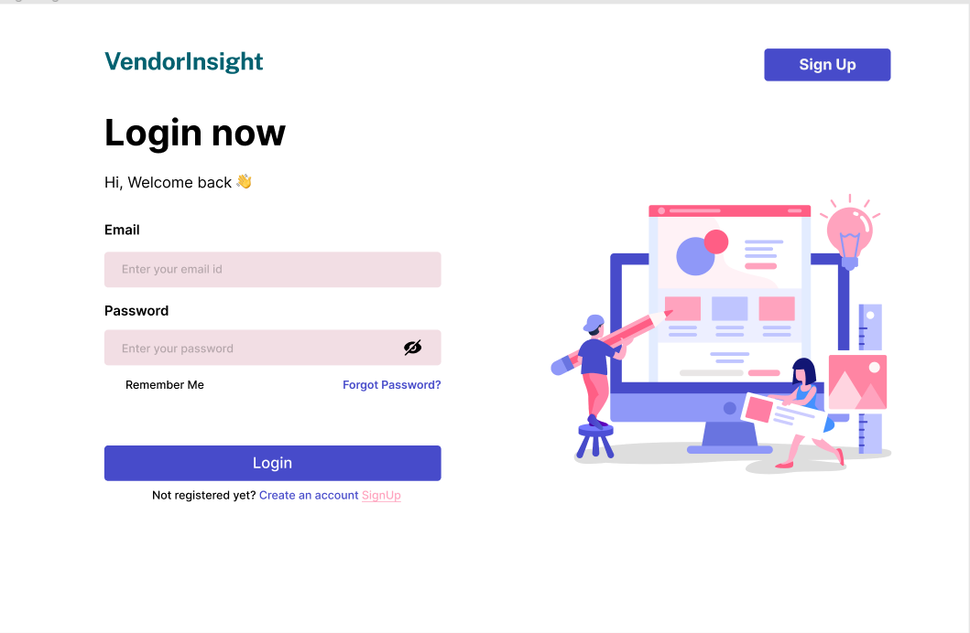

Figure : Login Page wireframe

Figure : Home Page Wireframe

Figure : Explore Products Wireframe

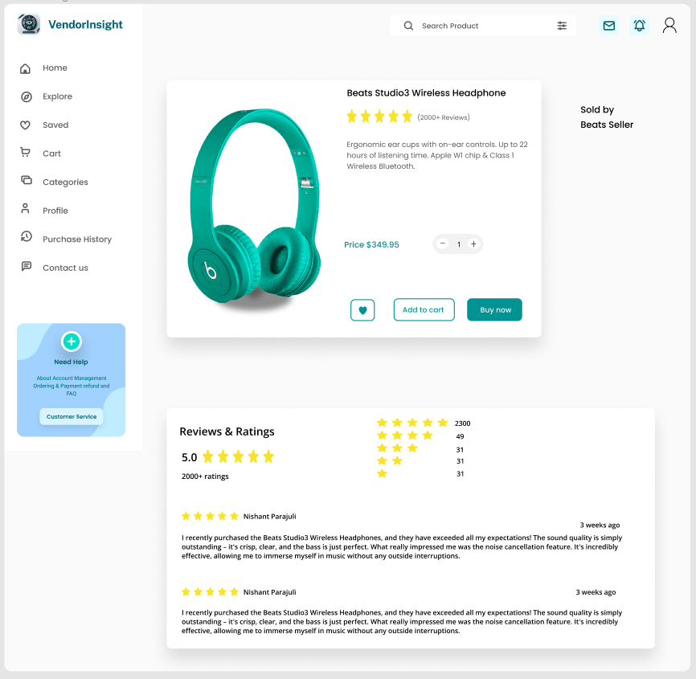

Figure : Product Page Wireframe

Figure : Vendor Dashboard Wireframe

Figure : Vendor Ordered Products Page Wireframe

Figure : Vendor Product Listing Page Wireframe